ParTee-GAMS

What Is What

1. Launch Screen



This screen appears when ever application get launched.

1. Home Screen

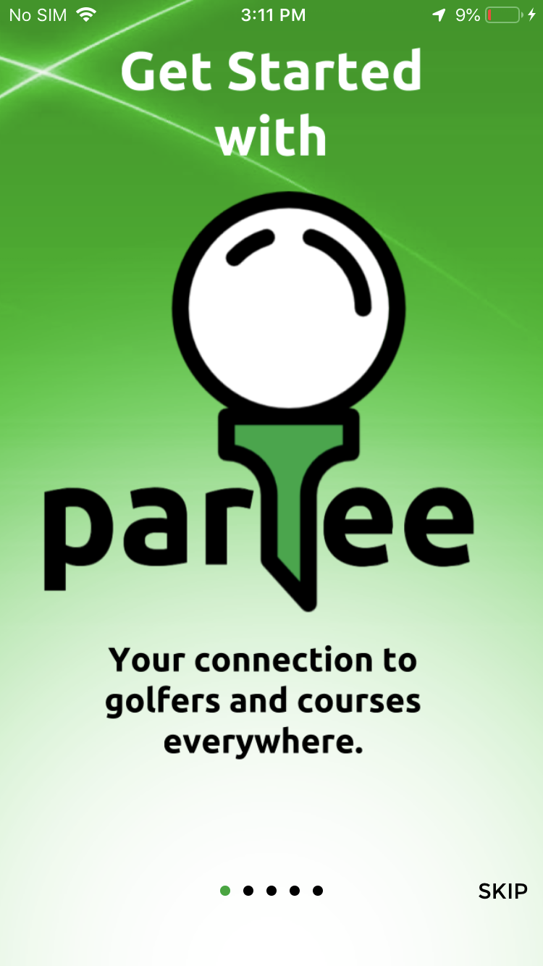

CLASS : LoginViewController

This screen Conatins images which tells to user about the application. How user can use the applications and what application have and all other important functionlity implemented throughoput the application.

1. Login Screen

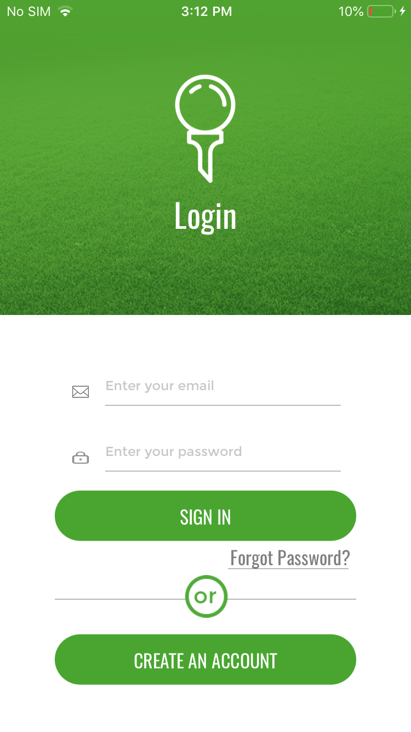

* CLASS : LoginViewController
* Login screen appears only first time when user install application.
* It contains Forgot Password button that wiil ask about the registered user ID with partee and after it will send a mail regarding forgot password to partee. After this processs partee will take care about forgot password.
* It contains CREATE AN ACCOUNT button that will redirect user to register acreen from where he can register theirself with partee.

1. Forgot Password Screen

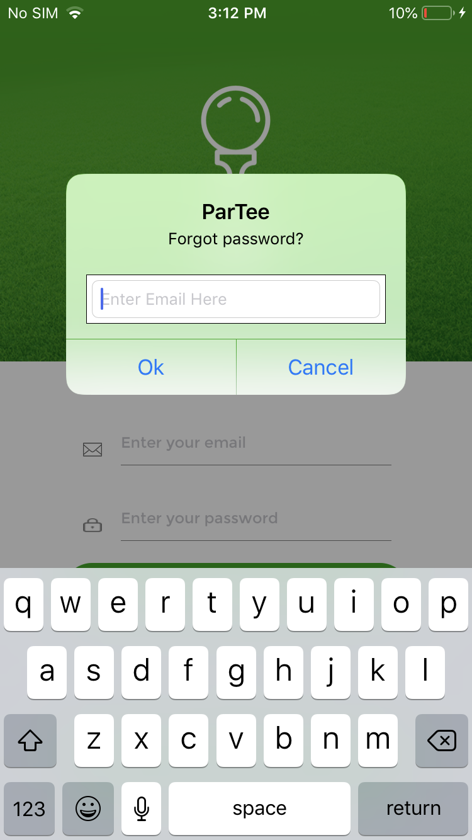

* CLASS : LoginViewController
* Forgot Password screen wiil ask about the registered user ID with partee and after that it will send a mail regarding forgot password to partee. After this processs partee will take care about forgot password.
* Partee will send a mail to user who requests for password that will conatin new password selected by partee. Once user get login with this password then it can change the password on edit profile screen.

1. SignUp Screen

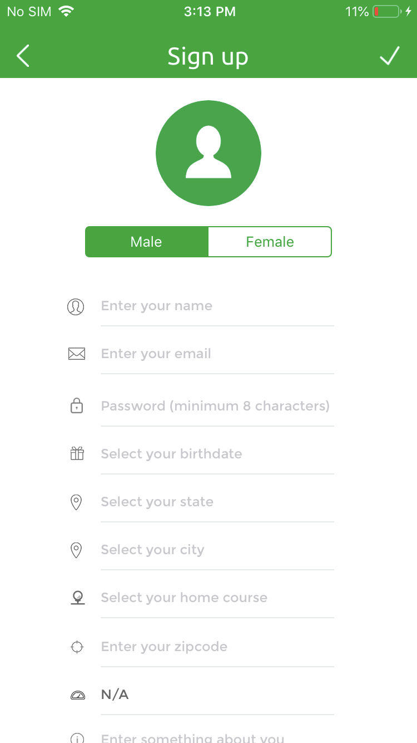

* CLASS : RegisterViewController
* Signup screen register users with details like name, user emailId, state, city, zipcode etc.
* It asks for users basic details like username, userEmail, birth date, state name, city name, zipcode, homecourse, handicap, password, about user details to register users with partee.
* It validate users details like useremail, password, zipcode. Users should provide a valid email ID, and password at least 8 characters long .
* It is fetching the list of cities from golfcourse table based on selected state by the users and after that it is fetching the list of courses available in city selected by the users.

6. Side Screen

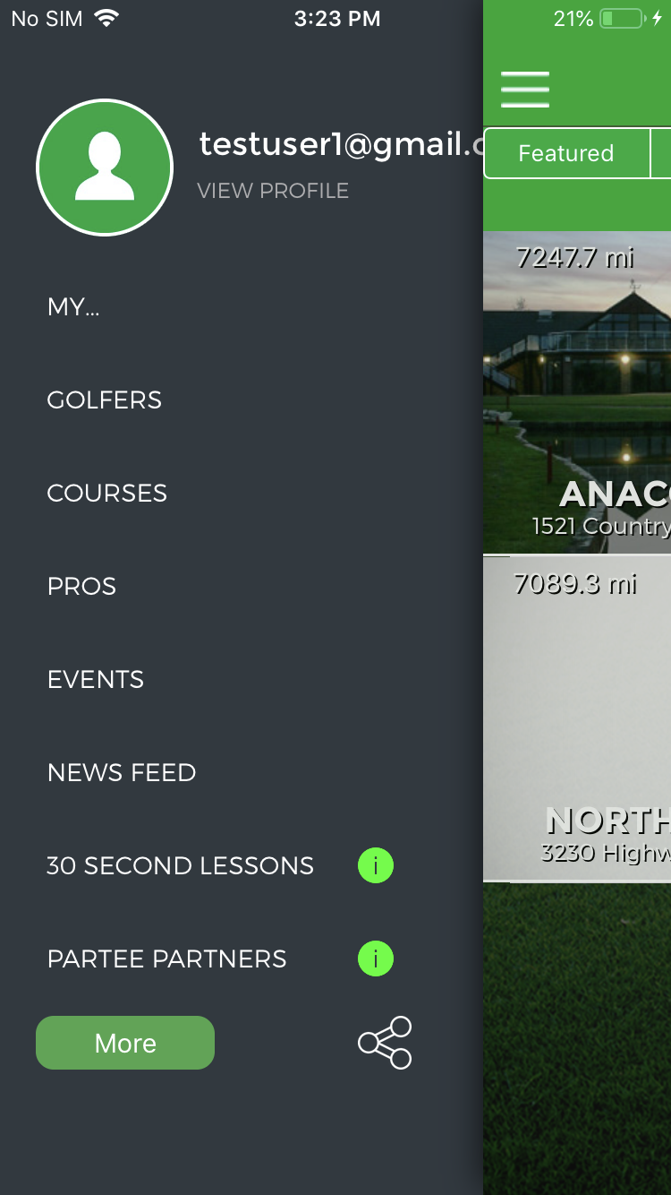

* CLASS : SideMenuViewController
* This is the side menu screen that conatins all the option frrom where user can go through the desired functionality like Golfers, courses, pro screen, Event screen, news feed screen, edit profile screen, More screen, friend Screen, Invitaion screen as well.

1. Courses Screen

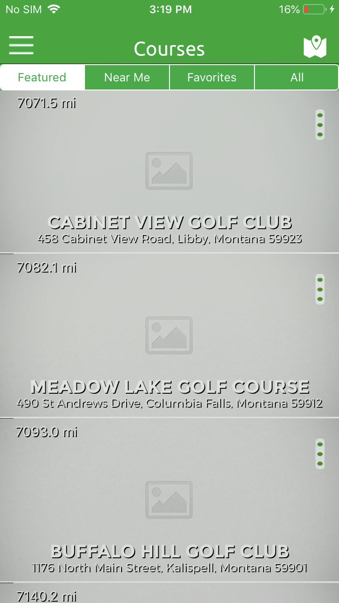

* CLASS : SpecialsViewController
* This is showing the list of golf courses details available in the quickblox database.
* It conatins basic details of golf courses like name of courses, adddress of course in which it lies, website of the course, contact number and image of the course.
* Every courses have a three dot button in the right top corner of the course image that will show a popup with buttons like favourite, info, map, direction,share.
* If user tap on favourite button available on blcak popup the it will marked as favourite golf course for that particular user. After that it will show on favourite golf course list.
* If user tap on info button then it will show the information about course on popup.
* If user tap on map screen then it will redirect the user to map screen that will show the dirction of golf course from users current location.
* If user tap on direction button then it will redirect the users to native map screen with golf course location information.
* If user tap on share button then it will open activity controller from where user can choose the social applications installed on user device from which user can share the golf course details via social applications.
* It have options like nearme, favourite, featured, All. Through which user can filter out the courses based on selected options.
* Nearme will show the nearby 20 courses of the users current location.
* Featured courses shows 20 fetaured courses. Featured course is the course that is marked as featured by admin on quickblox.
* Favourite will show the list of 20 favourite course that was mariked as favourite by users earlier.
* All will show the list of all courses available in database. Everytime it will show maximum of 25 courses per page but user can able to go next or previous 25 courses in the list.
* It also have map button on top most roght corner whhich will redirect the users to map screen. On map screen it will show the path between users current locations and nearest curses and also locate nearby courses of the users current locations.
* It also have a search button available on right bottom corner for all courses from where user will redirect user to courses search screen.

1. Course Preferences Screen

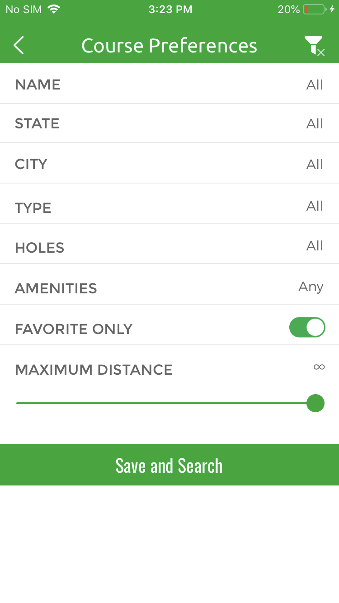

* CLASS : CoursePreferencesViewController
* It contains course prefernces from where user can choose their prefernces according to their need.
* From here User can choose state, course name, city, type of course, favorite courses to filter out the courses based on these preferences selected by the users.
* User can choose distance parameter to filter courses based on distance value.

1. Course Profile screen

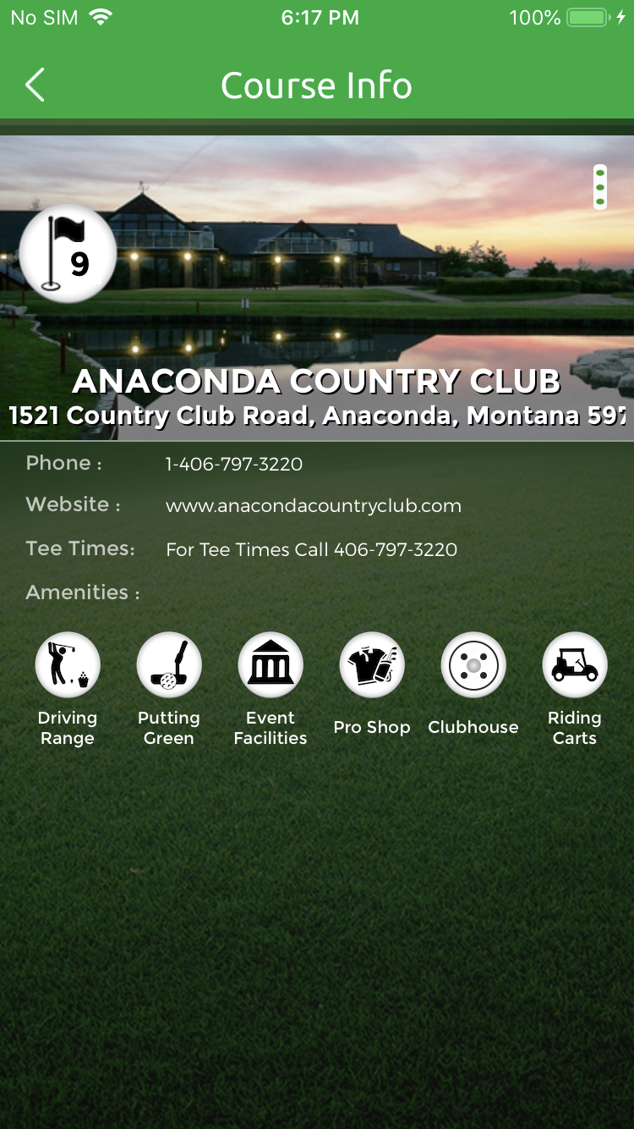

* CLASS : PurchaseSpecialsViewController
* This screen show the information about a golf course. Details regarding amenties, address, contact number, website and all othe details it have.

1. Map screen

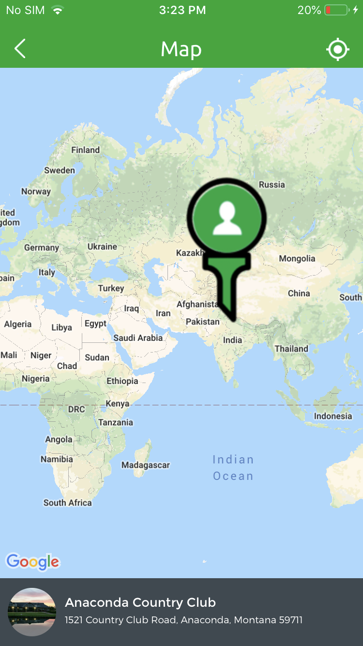

* CLASS : MapViewController
* Map screen shows path between nearby course of the user and current location of the user and also showing the nearby courses of the user current location.

1. Golfers Screen:

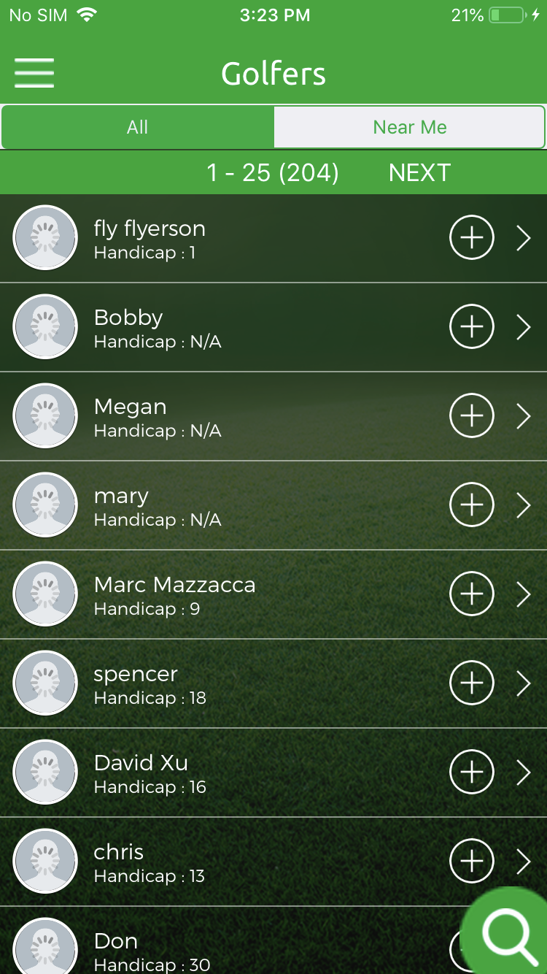

* CLASS : ViewUsersViewController
* This screen shows the list of golfers available in the quickblox database. From here user can send the request to other golfer.
* This Screen have two options nearme and all. Near me show the list of golfers nearby the users current location and all will show the list of all golfers.
* Maximum of 25 golfers can able to show on one page and if user want to load more golfers then it can load more just by press next button or if he wants to go pervious golfers then prev button is also avaliable.
* This screen also have search button that will redirect user to golfer search screen.

1. Golfers Search screen

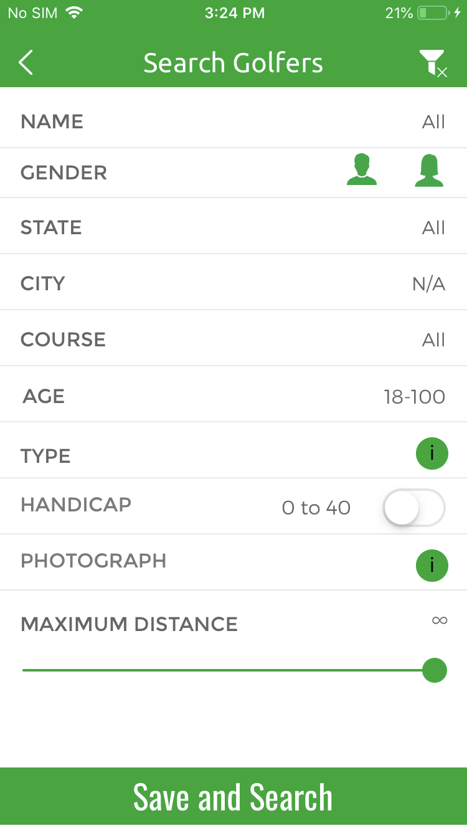

* CLASS : SettingsViewController
* It contains golfer prefernces from where user can choose their prefernces according to their need.
* From here User can choose state, course name, city, type of course, favorite golfers to filter out the courses based on these preferences selected by the users.
* User can choose distance parameter to filter golfers based on distance value.
* Type and photograph parameter functionality not implemented yet because this will implemented in next development phase.

1. Golfer Profile Screen

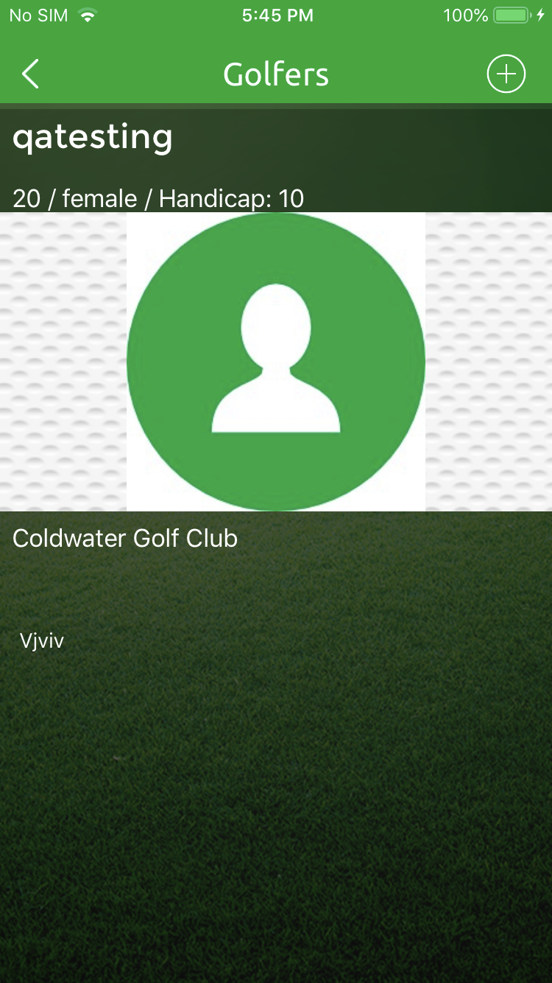

* CLASS : PreviewProfileViewController
* It will display all the details of golfer like golfer name, address, state, city, hadicap details, profile image and all other details.

1. Pro screen

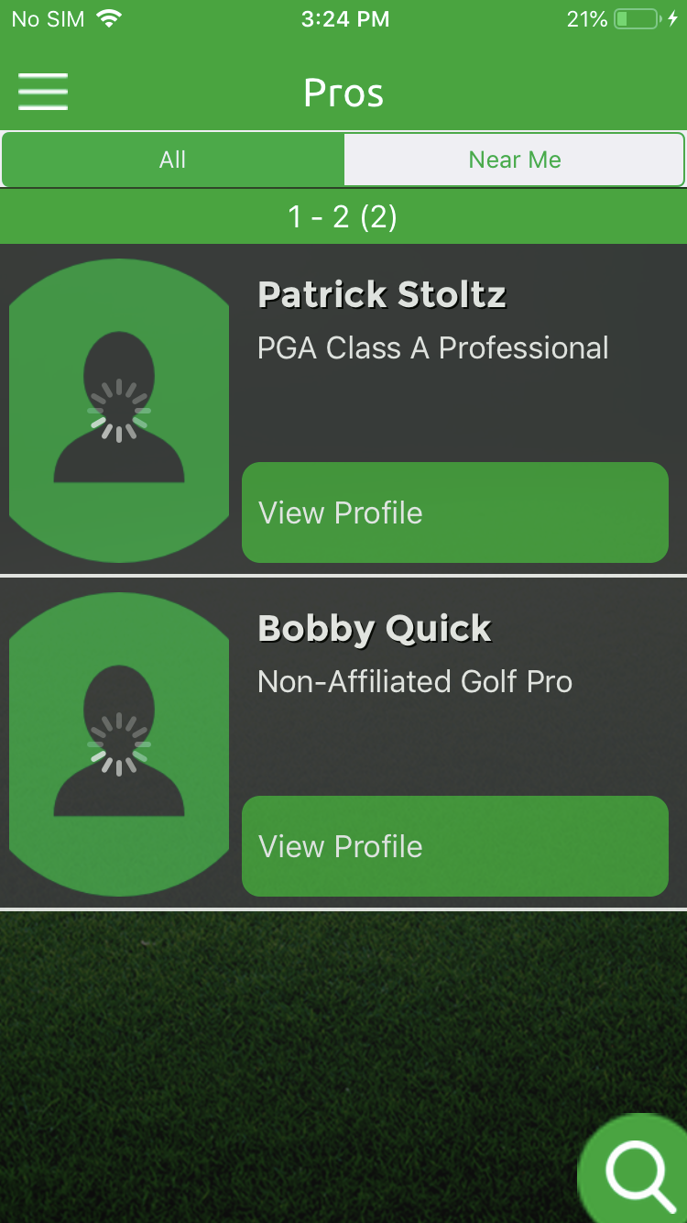

* CLASS : ViewUsersViewController
* This screen shows the list of professional available in the quickblox database. Professional is the person that have responsibilty to one or more pro.
* This Screen have two options nearme and all. Near me show the list of pro nearby the users current location and all will show the list of all pro.
* Maximum of 25 pro can able to show on one page and if user want to load more golfers then it can load more just by press next button or if he wants to go pervious pro then prev button is also avaliable.
* This screen also have search button that will redirect user to pro search screen.

1. Pro Search screen

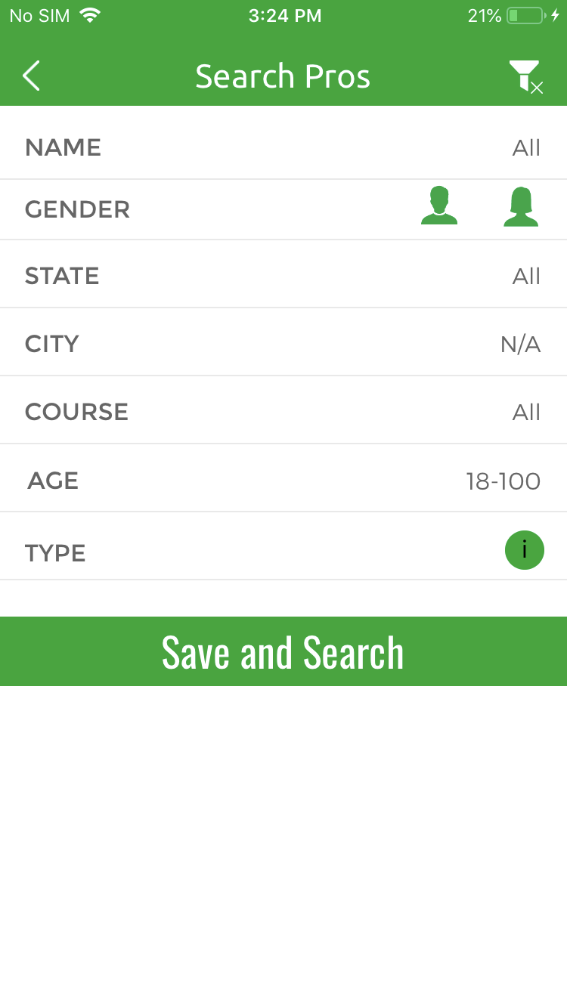

* CLASS : SettingsViewController
* It contains pro prefernces from where user can choose their prefernces according to their need.
* From here User can choose state, course name, city, type of pro, favorite pro to filter out the pro based on these preferences selected by the users.
* User can choose distance parameter to filter pro based on distance value.
* Type and photograph parameter functionality not implemented yet because this will implemented in next development phase.

1. Pro Profile Screen

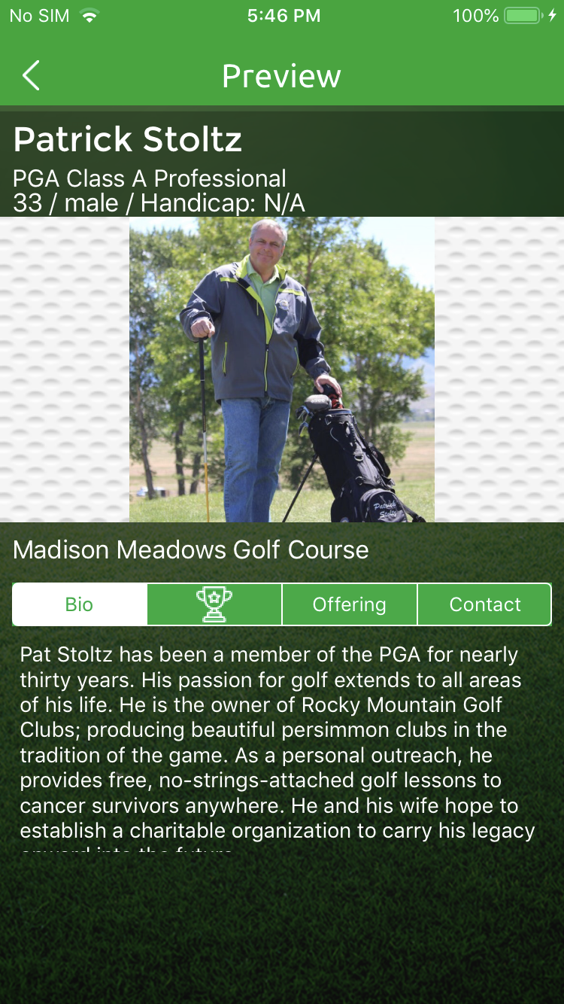

* CLASS : PreviewProfileViewController
* It will display all the details of professional like golfer name, address, state, city, hadicap details, profile image and all other details.

1. Invitation Screen

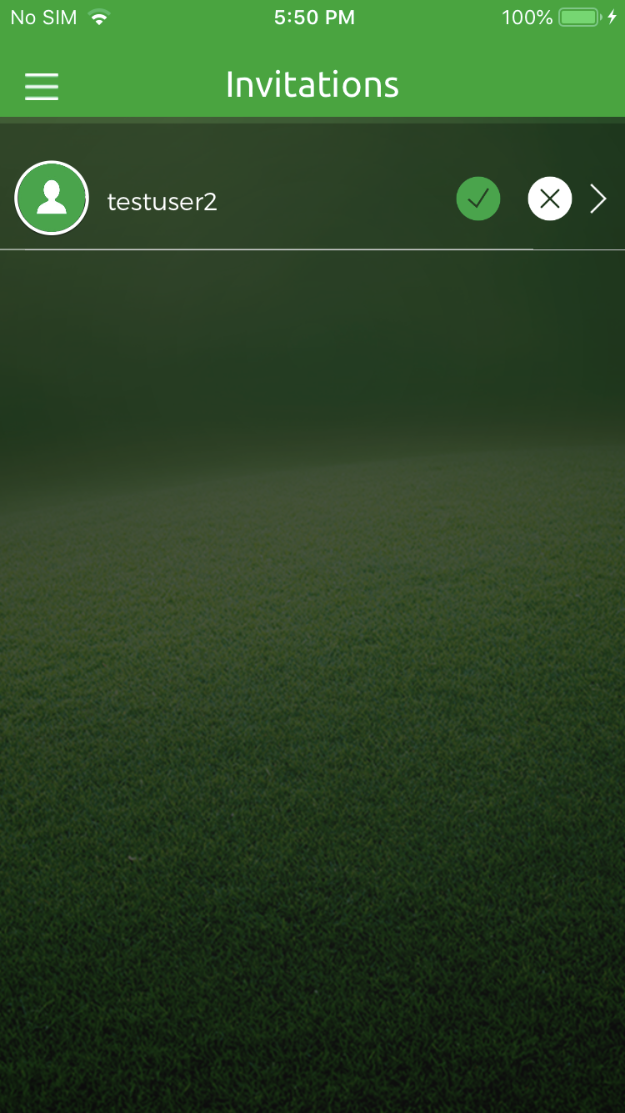

* CLASS : InviteViewController
* This will show all the requests from other golfers.From here user can accept or decline the request. If user accept the respective request from other golfer then it will make friend and will show on friend screen from where he can start the chat.

1. Friend Screen

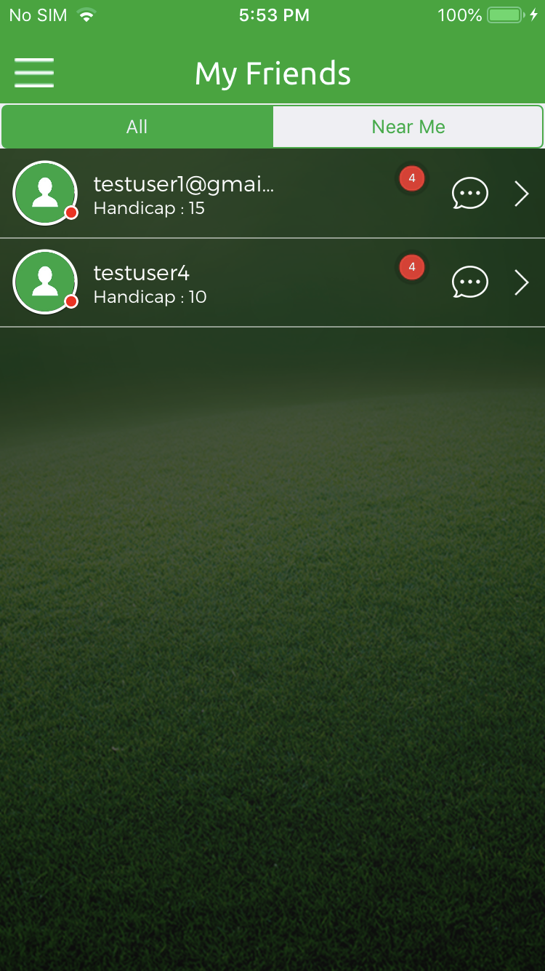

* CLASS : ViewUsersViewController
* This will contain all the list of frineds for which user accepts requests earlier before. From here he can go to chat screen where he can start chat with other golfer.
* If any other golfer sent message to user then here a label shown in red which indicates how many message any gofer sent to you that you have not read yet.
* If user tap on golfer cell then it redirect user to profile of your friend.

19. Chat Screen

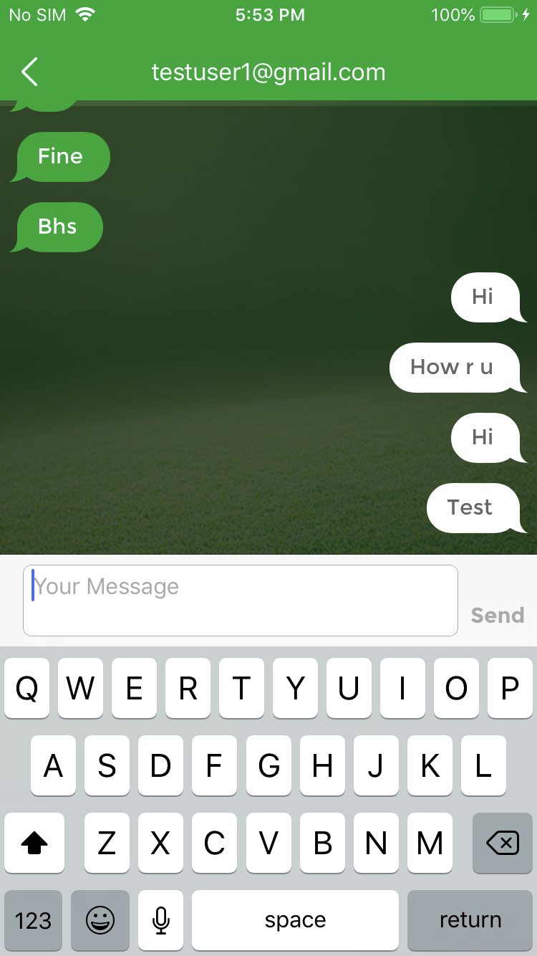

* CLASS : DemoMessagesViewController
* From her user can chat with other golfer that have become friend now.

20. Event Screen

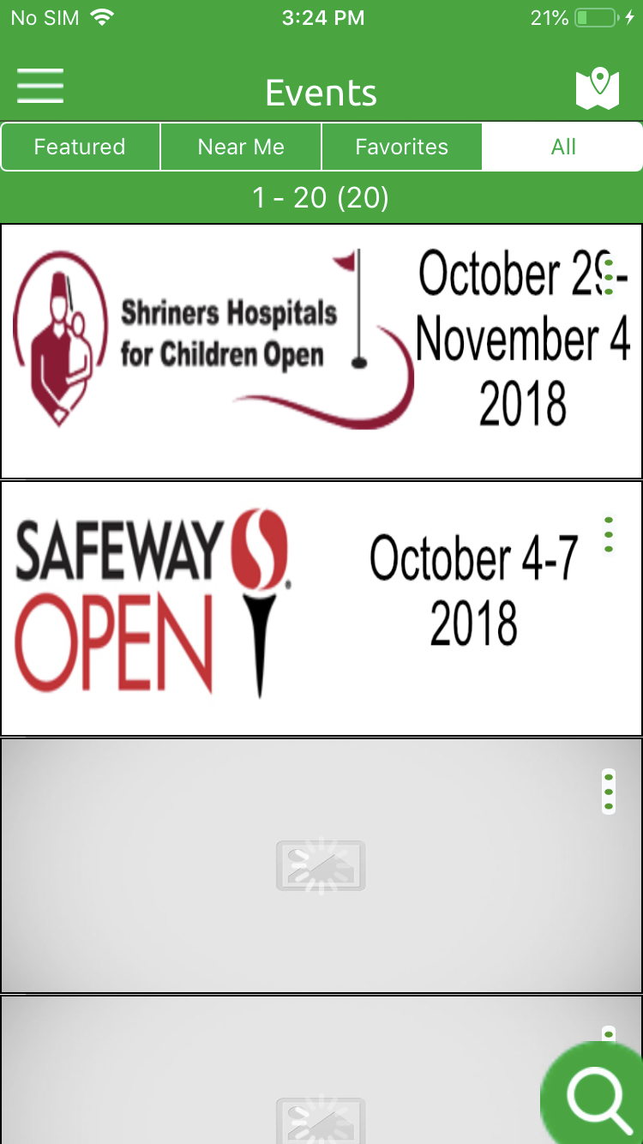

* CLASS : EventViewController
* This is showing the list of events details available in the quickblox database.
* It conatins basic details of events like name of events, adddress of events in which it lies, website of the events, contact number and image of the events.
* Every events have a three dot button in the right top corner of the course image that will show a popup with buttons like favourite, info, map, direction,share.
* If user tap on favourite button available on blcak popup the it will marked as favourite events for that particular user. After that it will show on favourite events list.
* If user tap on info button then it will show the information about course on popup.
* If user tap on map screen then it will redirect the user to map screen that will show the dirction of events from users current location.
* If user tap on direction button then it will redirect the users to native map screen with events location information.
* If user tap on share button then it will open activity controller from where user can choose the social applications installed on user device from which user can share the events details via social applications.
* It have options like nearme, favourite, featured, All. Through which user can filter out the events based on selected options.
* Nearme will show the nearby 20 events of the users current location.
* Featured courses shows 20 fetaured events. Featured events is the events that is marked as featured by admin on quickblox.
* Favourite will show the list of 20 favourite events that was mariked as favourite by users earlier.
* All will show the list of all events available in database. Everytime it will show maximum of 25 events per page but user can able to go next or previous 25 events in the list.
* It also have map button on top most roght corner which will redirect the users to map screen. On map screen it will show the path between users current locations and nearest event and also locate nearby event of the users current locations.
* It also have a search button available on right bottom corner for all event from where user will redirect user to event search screen.

1. Event Map Screen

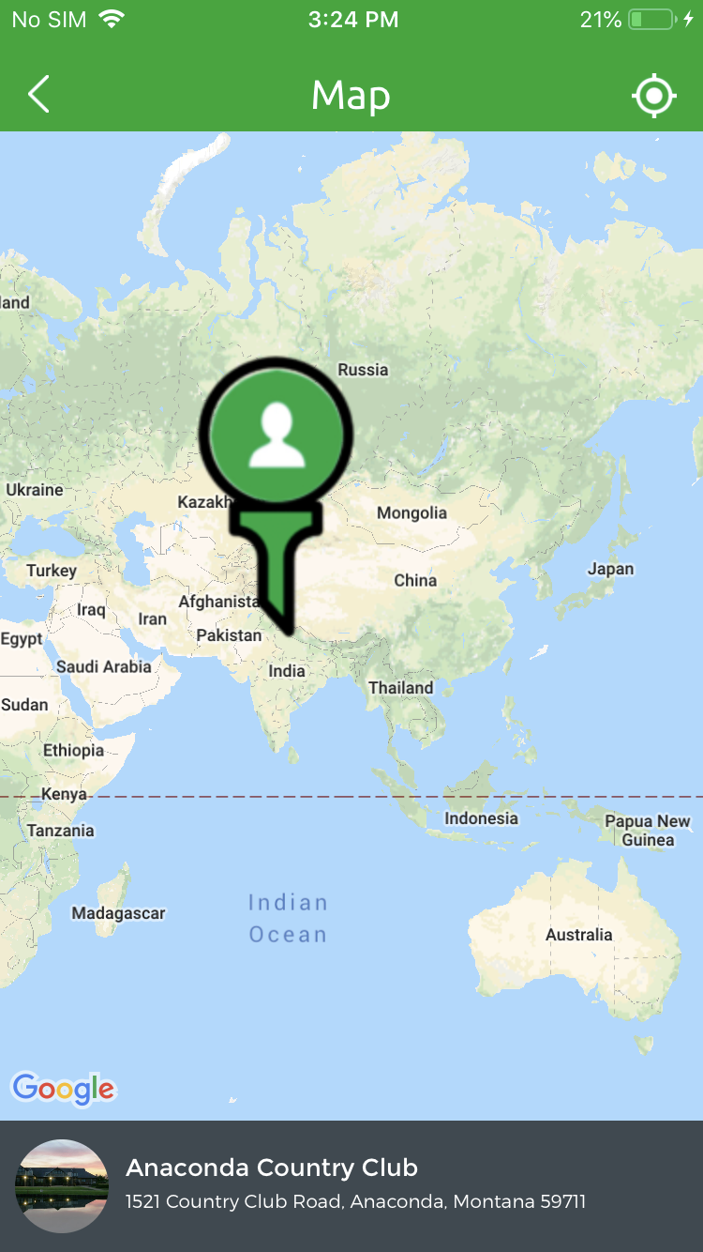

* CLASS : MapViewController
* Map screen shows path between nearby event of the user and current location of the user and also showing the nearby event of the user current location.

1. Event Map Screen

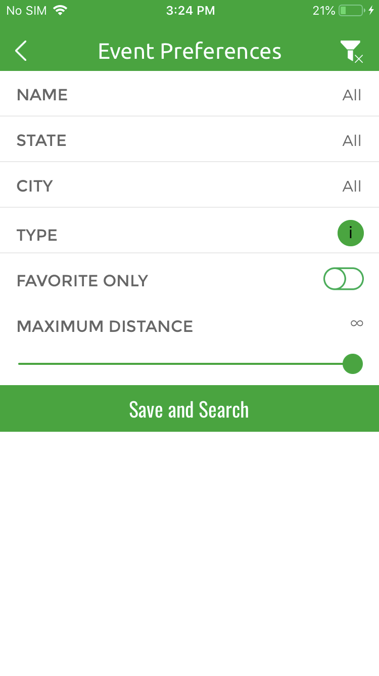

* CLASS : EventPreferncesViewController
* It contains event prefernces from where user can choose their prefernces according to their need.
* From here User can choose state, course name, city, type of event, favorite event to filter out the event based on these preferences selected by the users.
* User can choose distance parameter to filter event based on distance value.

1. News Feed Screen

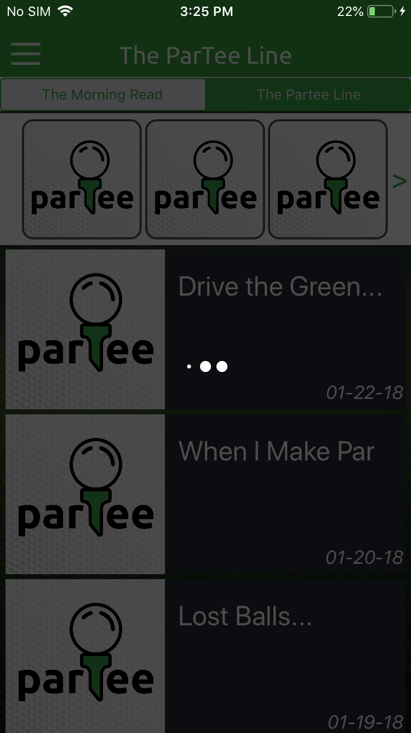

* CLASS : NewsFeedVc
* It shows the news feed list avilable on partee line blog. It conatins all the details like date of feed, publisher name, name of the feed etc.
* Here insta feed also showing on top of the screen where user able to see the insta feed image and also fetch next or previous feeds.

1. Article Feed Details

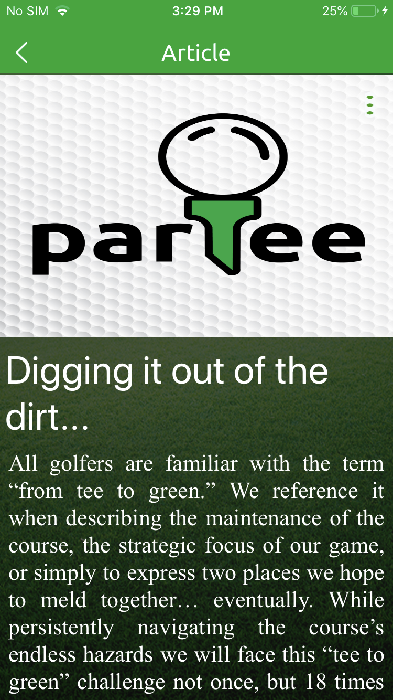

* CLASS : ArticleDetailsVC
* This shows news feed details and all other details related to news feed.
* It contains three dot button from where user can share the news feed and also change the font size of the text as well.

1. More Screen

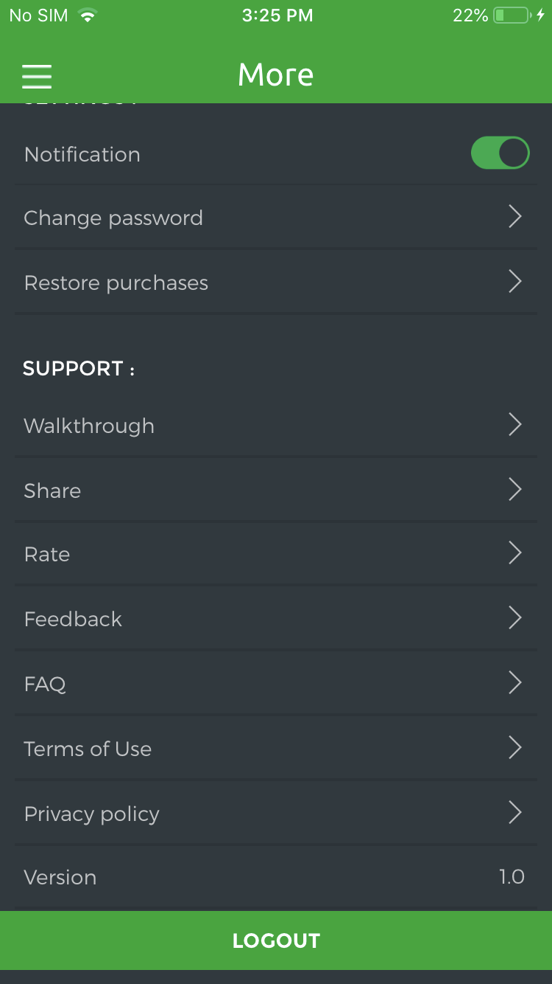

* CLASS : MoreViewController
* From here user can enable notification throughout the application that user recieves while request or message recieves.
* From here user can change the password and share the application link via social application installed in the device.
* Using walkthrough user can get the details about the application using images. User can rate the application as well. User can share feedback about the partee.
* From here user can go through the privacy policy and terms and conditions of the partee as well.

26. Edit Profile Screen

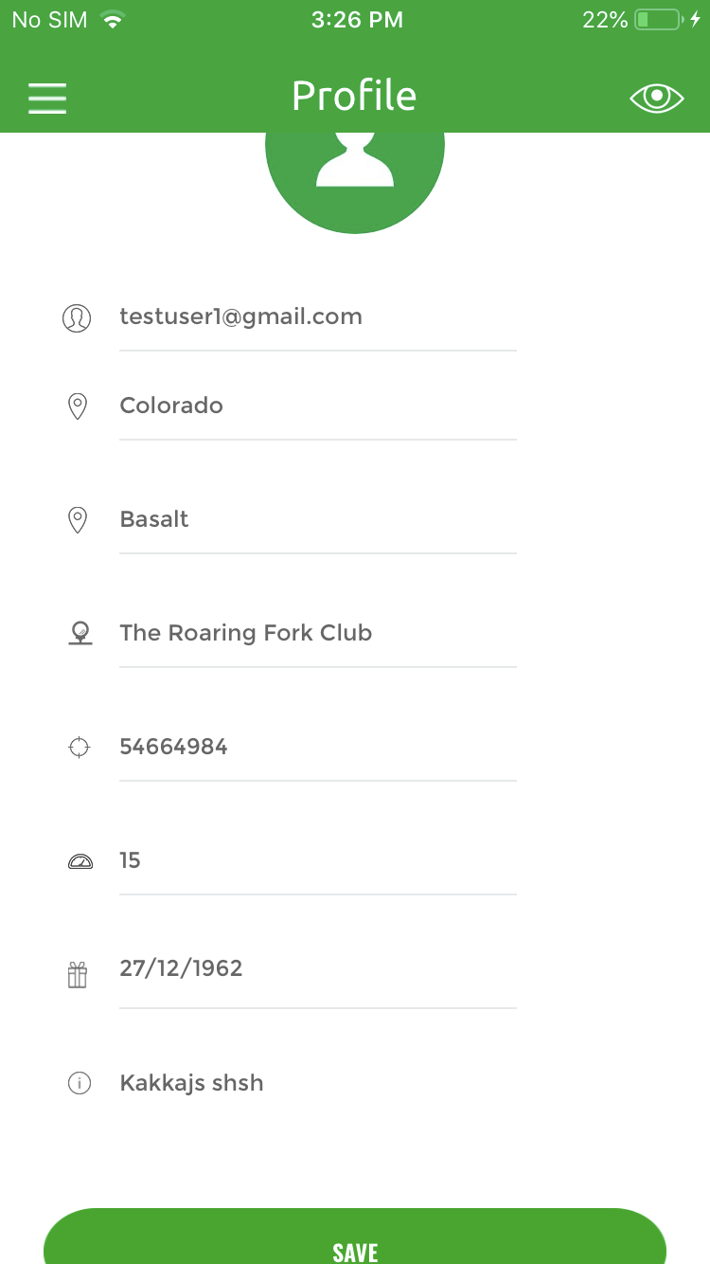

CLASS : EditProfileViewController

From here user can change their profile information like name, state, city, zipcode, date of birth, Course etc.